**Plan2Value - Change Request Form**

1. **Title**

Initialize the version specific conversion factors

1. **Description of Change**

The script initializes two reference tables that the loaders and reports use.  These two tables have been designed to be version specific as the values can change over time.   Since Catalin has created a new version in Prod, 2019 and rolled forward to 2020 these tables are currently empty.

The yearend rollover process will populate the table for the new versions on a go forward bases, but this script needs to be run on the initial version which was missed, so the script is required to be run once for 2019 and once for 2020.

In the Reserves process after the initial version is created, versions should really only be created by the rollover and copy version loaders in the application and not how the 2019 version was created, therefore eliminating the require of running this script in the future.

The values in the tables can be maintained by manual update by editing or adding new countries on the screens shown below.

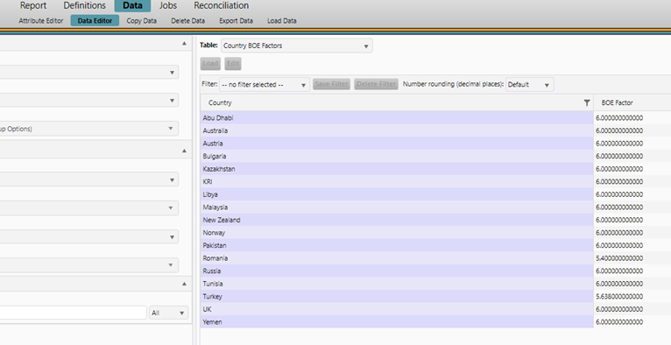

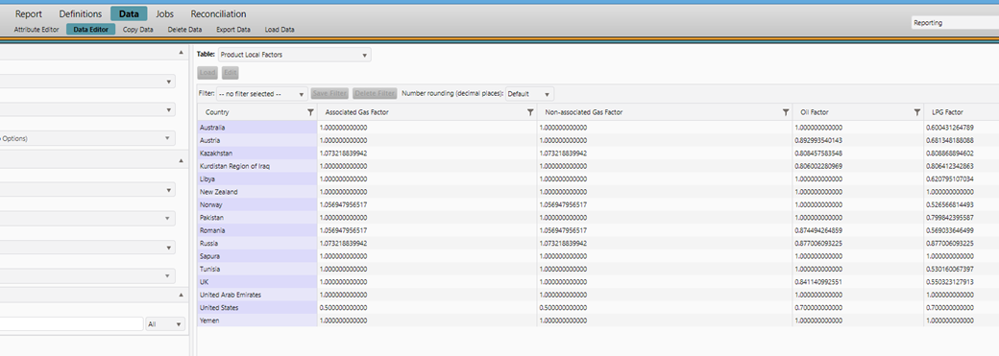

1. **Implementation Steps**
2. Backup the database
3. Login to SQL Server Management Server as a privileged user
4. Connect to the Production Aucerna Reserves database
5. Run the SQL script the statement below:

select * from PLZ_LINK_VW where CONTEXT_NAME = 'RECONCILIATION';

1. Replace 99999 with the LINK_ID from the about query for the 2019 version in the script “OMV Initialize Factors.sql” file
2. Run the queries
3. Replace 99999 with the LINK_ID from the about query for the 2020 version in the script “OMV Initialize Factors.sql” file
4. Run the queries
5. **Test Steps**
6. Log on to Aucerna Reserves
7. Go to the Reporting🡪Data🡪Data Editor page
8. Select the 2019 Version
9. From the Table drop down select Production Local Factors
10. Click the Load button
11. Values should appear
12. Select the 2020 Version
13. Click the Load button
14. Values should appear
15. From the Table drop down select Country BOE Factors
16. Click the Load button
17. More values that just Default should appear
18. Select the 2019 Version
19. Click the Load button
20. More values that just Default should appear
21. **Affected Modules and Interfaces**

Please tick below the relevant boxes and provide details if the case:

Dataflow (mapping template, report)

Economics (regime, report)

Financials

Portfolio

Reserves

Interface Reports

Details: PowerBI report

Interface Tools

Details: n/a

1. **Outage Plan**

Please tick below the relevant boxes and provide details if the case:

No

Yes

1. **Back-out Plan**

Please tick below the relevant boxes and provide details if the case:

No

Yes

* Details: Restore the database backup prior to the change.

1. **Approval**

* P2V Core Team (Subject matter experts)
* OMV Application Owner